DBMS Lab Exam
Tables of the Database
Name: Dheeraj Chaudhary
Roll: 17BCS009

Table 1: Patient
* Added Age, Gender and Did columns and one Pid number
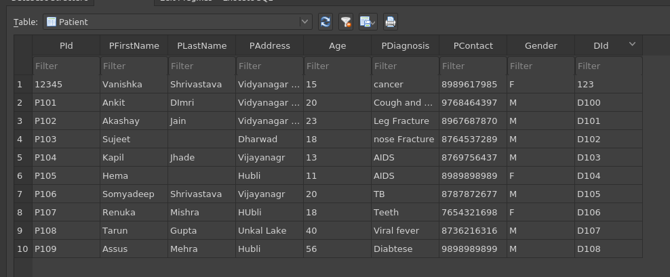

Table 2: Doctor
* Added DoTreatment and one Did number
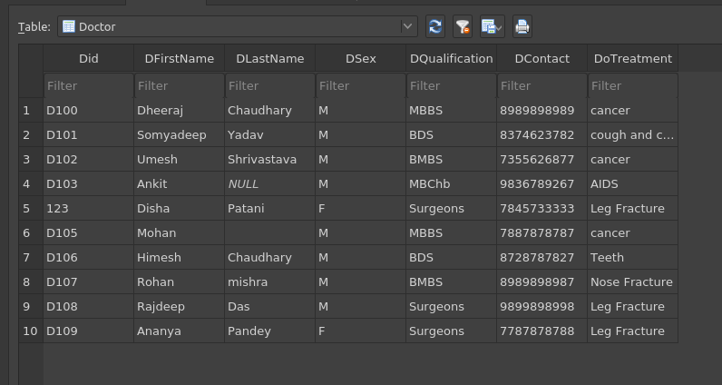

Table 3: Nurse
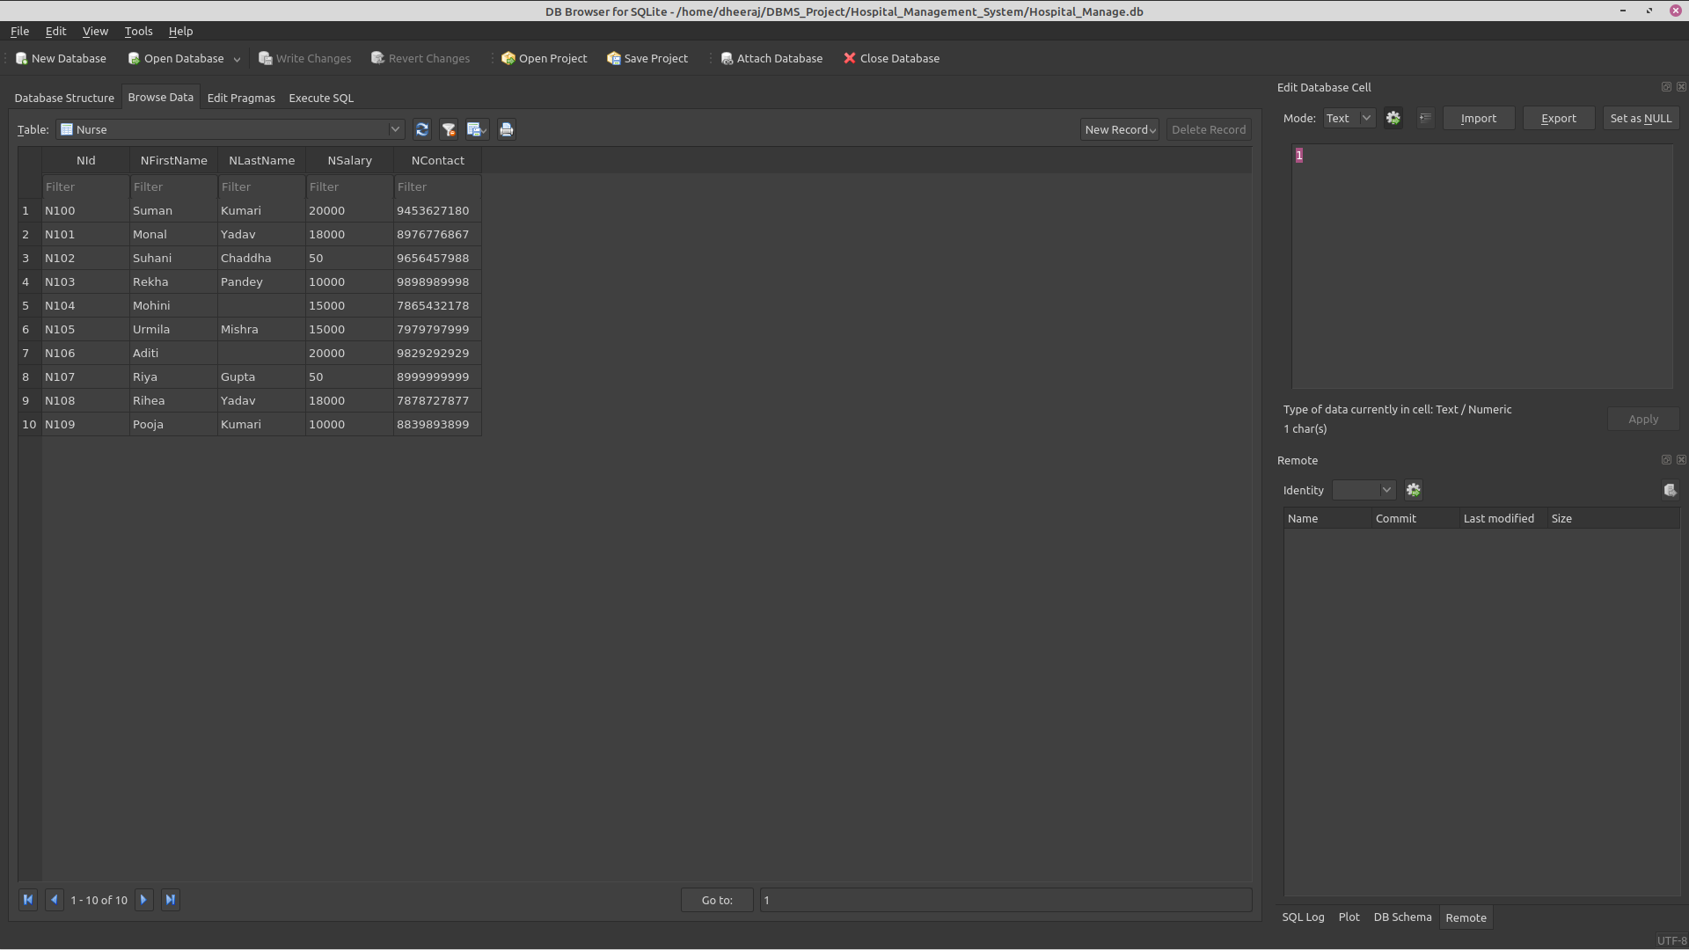

Table 4: Hospital

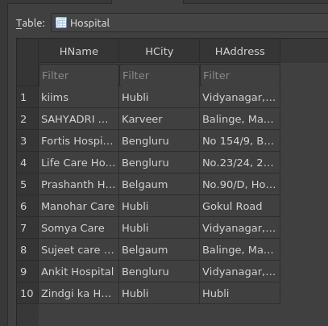

Table 5: Medical Record

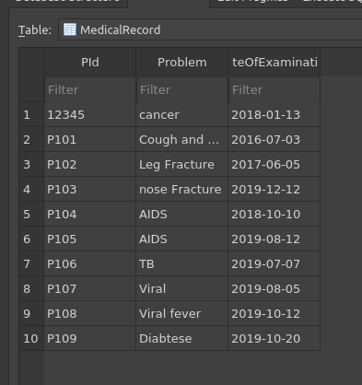

Output 1:
Query1: SELECT * FROM
Patient NATURAL JOIN MedicalRecord WHERE (MedicalRecord.DateOfExamination='2018-01-13');
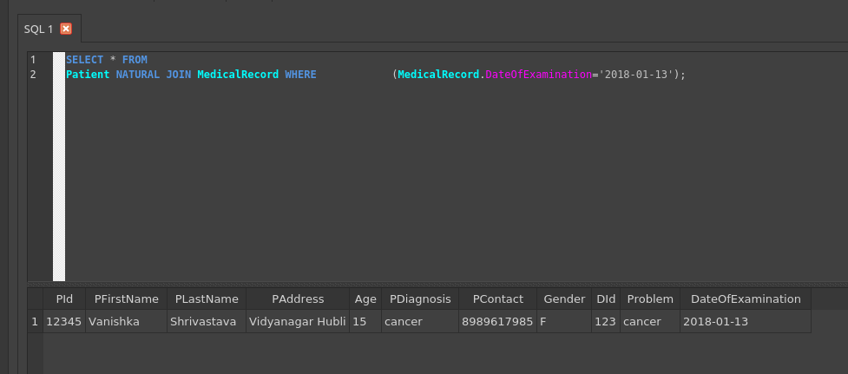

Output 2:
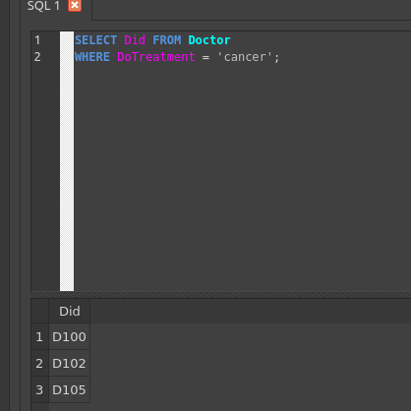

Output 3:
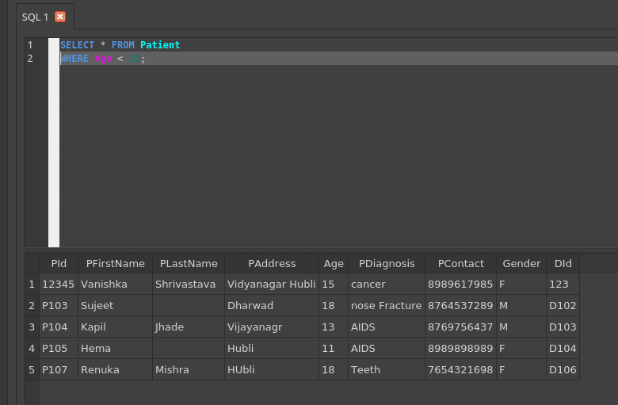

Out

Output 4:

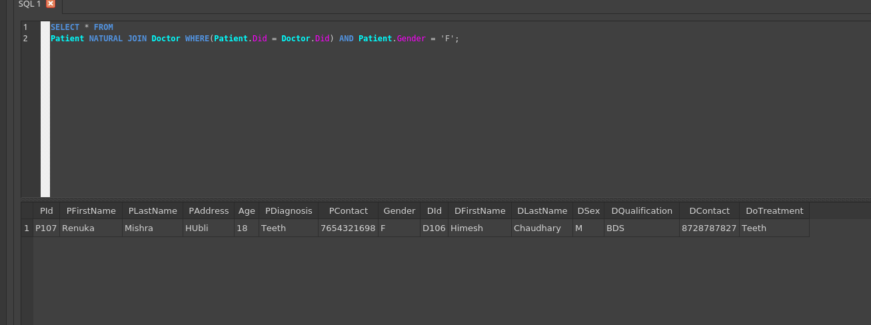

Output 5:

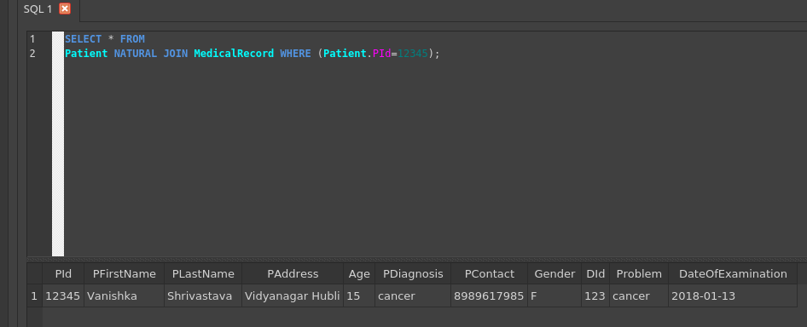

Query Used

Query2: SELECT Did FROM Doctor
WHERE DoTreatment = 'cancer';

Query3: SELECT * FROM Patient
WHERE Age < 20;

Query 4: SELECT * FROM
Patient NATURAL JOIN Doctor WHERE(Patient.Did = Doctor.Did) AND Patient.Gender = 'F';

Query5: SELECT * FROM
Patient NATURAL JOIN MedicalRecord WHERE (Patient.PId=12345);

